I was using code currently available (originalPWM.ino), as developed by other student in previous years. However, the code would map the field in such a way that both Hx and Hy reached their maximum magnetic field (MF) generation strength at different input currents. I placed the tip of the Gaussmeter at the centre of the workspace (Fig. 1, 2), and recorded the following data:
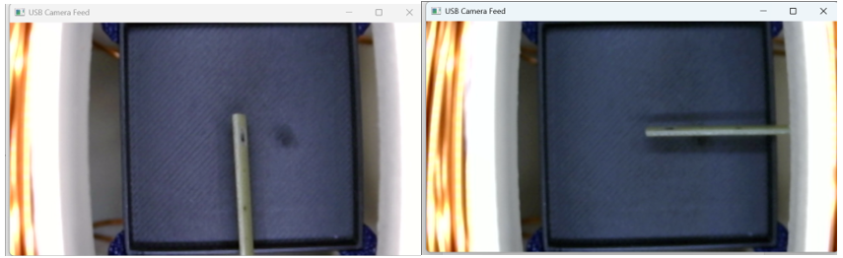
(b)
(a)
Figure 1. Gaussmeter placement for (a) Hx and (b) Hy field measurement.

The B-field for the Hy coil pair would peak at 4A, whereas that for Hx did it at 10A. However, I also noticed the PWM values for both inputs were lower than 255. Hence, to calibrate the maximum field generated by the system (mT), I recalculated the code parameters for the coil pairs to generate their maximum field at ~10A after 3 trials (Helmholtz.ino):

This indicates the current system design:
1. Due to heat generation, at currents higher than 8A, the field strength decreases, even if the PWM increases.
2. Limits the Hy maximum field to 11 mT at ~10A.
- In order to generate a stronger MF, more coil turns would be needed along this coil pair, but this strength was determined to be good enough for this project.

